Lab 1: Film Ranking (The Basics)

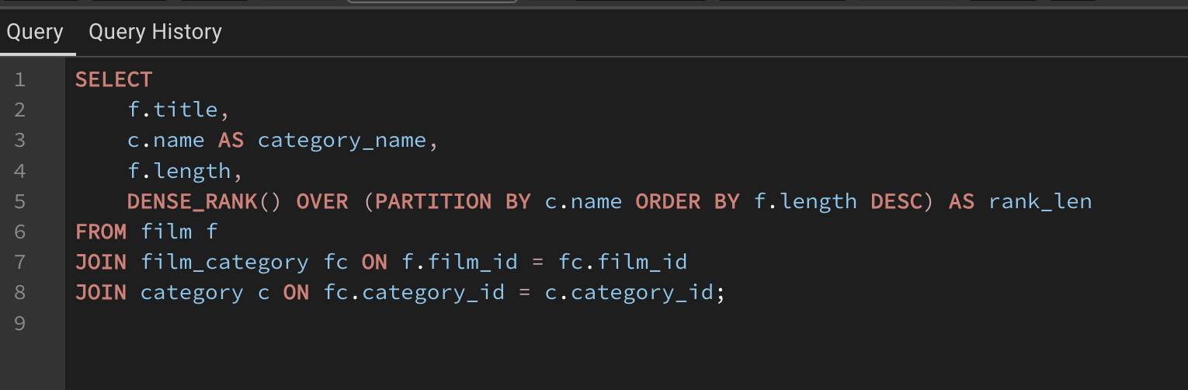
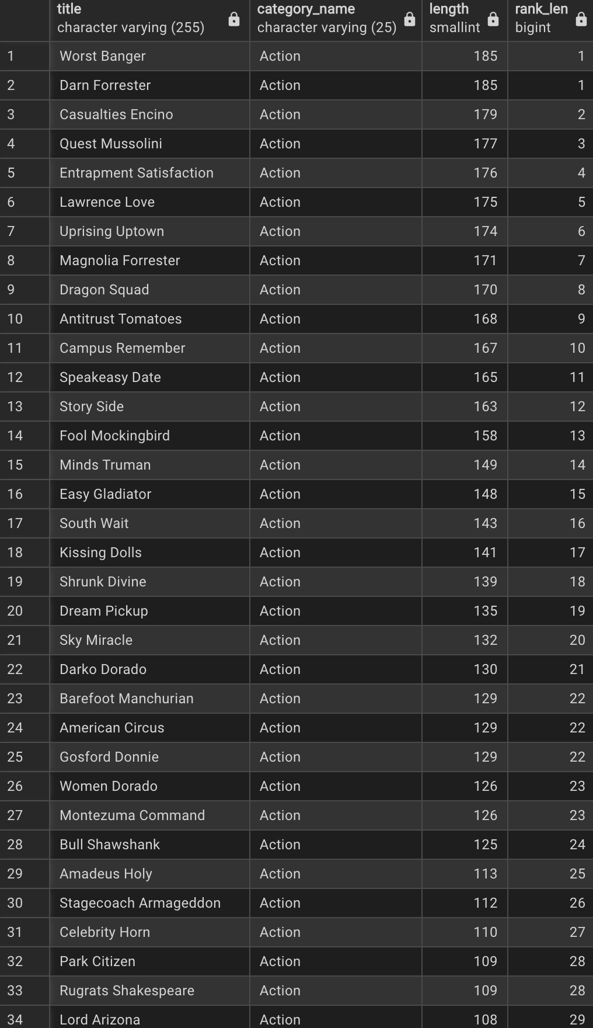
Lab 2: Growth Analysis (Time Series)
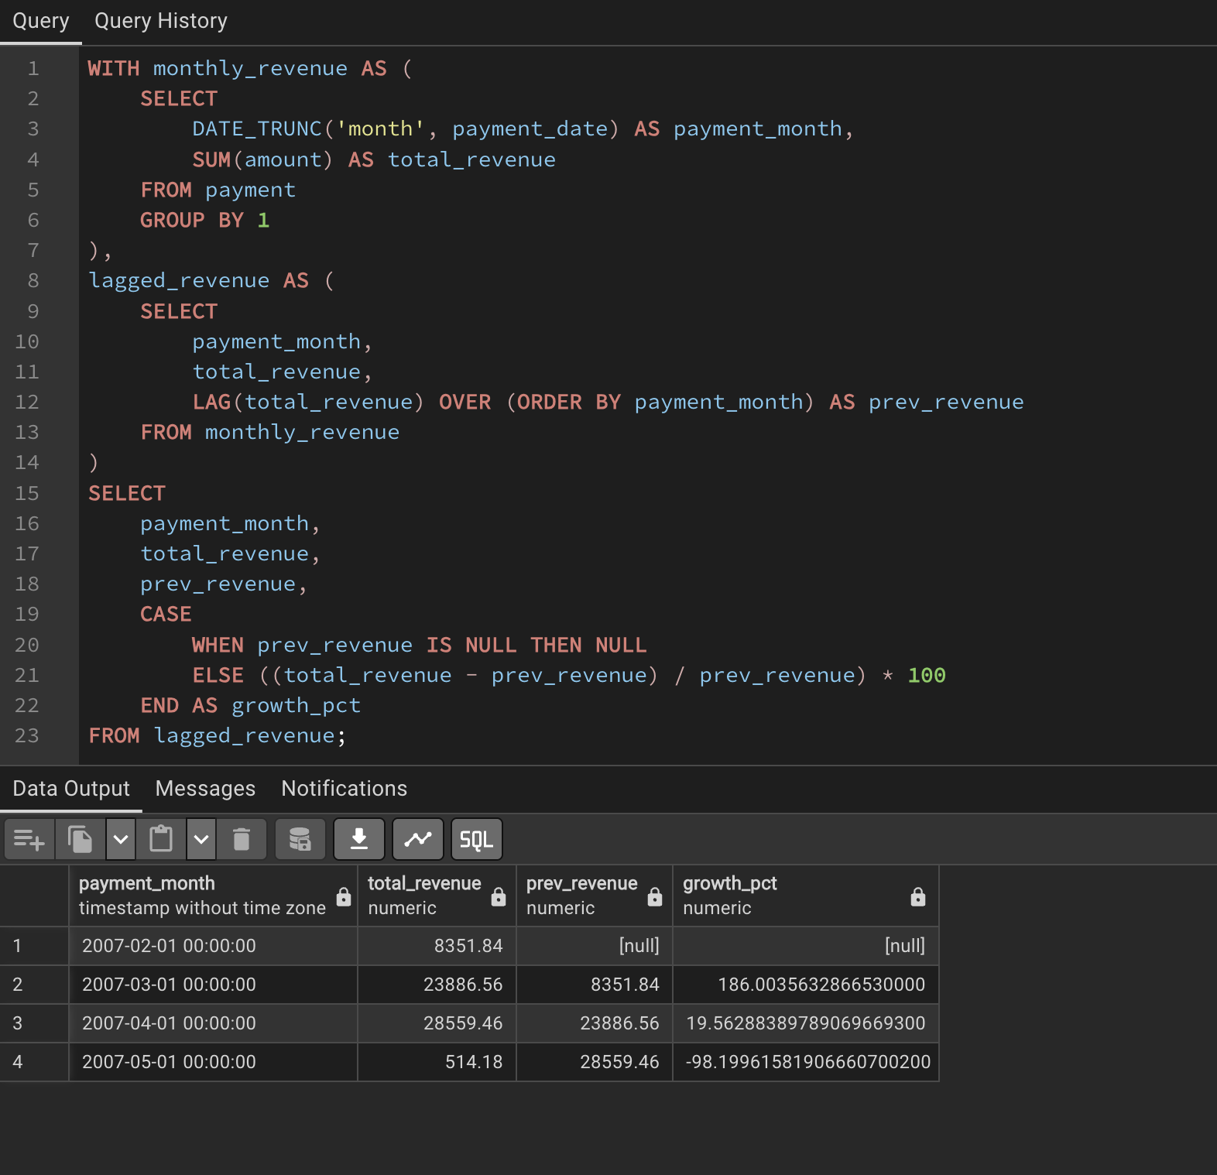

Lab 3: Customer Lifetime Value (Running Total)

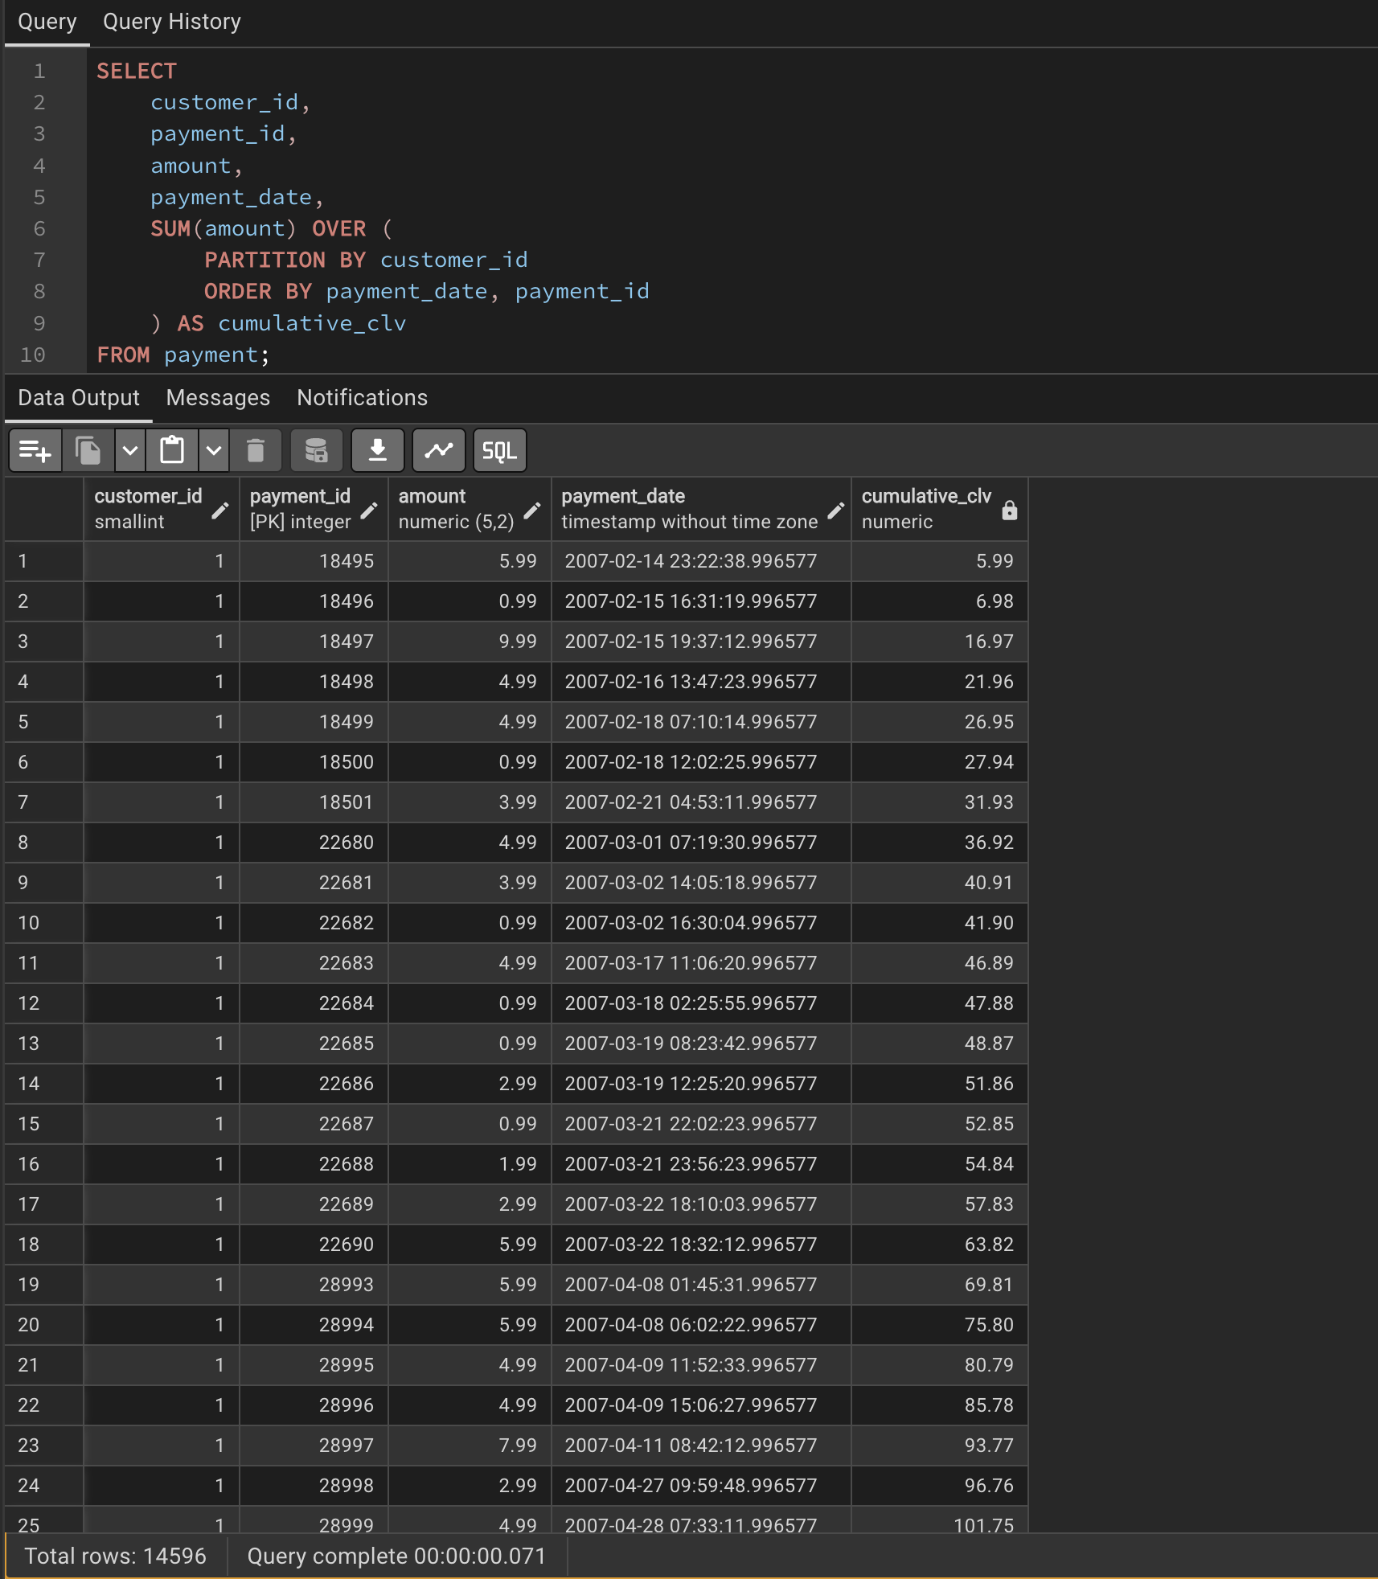

Lab 4: The ”Top-N” Filter Challenge

